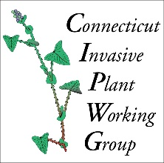
CIPWG BULK REPORT FORM

Please report your work for any activities that have occurred this year - lectures, invasive plant management events, educational outreach, workshops taught, etc.
Use this form or the ONLINE REPORT FORM (cipwg.uconn.edu).
WHO SHOULD SUBMIT A REPORT?
CIPWG members who have actively participated in invasive plant management programs, activities, educational events, or training sessions as part of their employment or in a volunteer capacity; written articles or created educational materials; or participated in any other way in related activities.
**PLEASE TYPE YOUR REPORT**
Name of Reporter:

Email:

Location (Town)  (Town + state if not in CT) | Educator/  Leader (if different than reporter) | Title/Short Description of Program/Outreach/ Management Activity (and date or month(s) activity occurred) | # Participants/ Attendees | # Hours  Contributed (educator(s) and participants)

Send your completed form to alyssa.siegel-miles@uconn.edu.

